BIT4139: ETHICAL HACKING AND COUNTER MEASURES
Student details
Student Name: Wendy Jane
Admission Number: BSCCS/35574/2024
Course: Computer Science
Unit Code: BIT4139
Unit Name: Ethical hacking and counter measures
Lecturer Name: Mr. Michael Nyoro
Semester/Academic Year: 2025/2026
Project details
Selected Technologies: Kali Linux, Nmap

Contents
TASK 1: SYSTEM INFORMATION GATHERING(FOOTPRINTING 3
View network interfaces 3
View routing table 3
DNS footprinting 4
TASK 2: NETWORK SCANNING 5
Basic host scan 5
Fast port scan 5
Service version detection 6
TASK 3: VULNERABILITY ASSESSMENT 6
Service and version enumeration 6
Vulnerability Script Scan 7
Port Risk Analysis 7
TASK 4: LOG AUDITING 8
Authentication Log Review 8
Login History Review 8
Current User Session Check 9
PROCESS OF ETHICAL HACKING 9
STEP 1: INFORMATION GATHERING 9
Identify target institution 9
Identify institutions IP address 10
Verify the Institution Website 10
Identify Open Services 11
Service version detection 11
Identify Technologies Running on the Website 12
STEP 2: SCANNING AND ENUMERATION 12
Discover all open ports 12
Identify the operating system 13

TASK 1: SYSTEM INFORMATION GATHERING(FOOTPRINTING)

View network interfaces
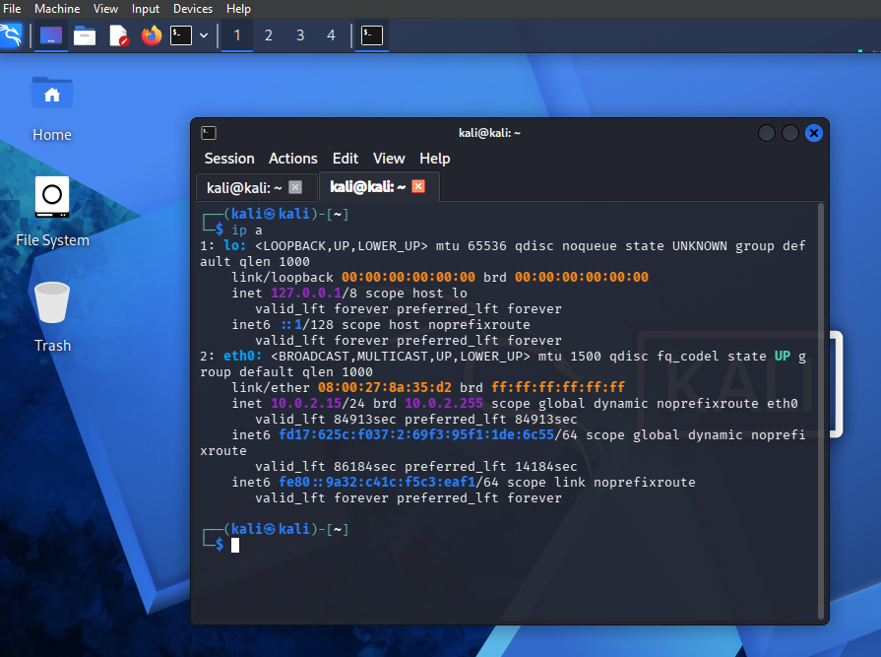
Displayed network interfaces and IP addressing information of the system using the ip a command in Kali Linux to identify active network configuration.

View routing table
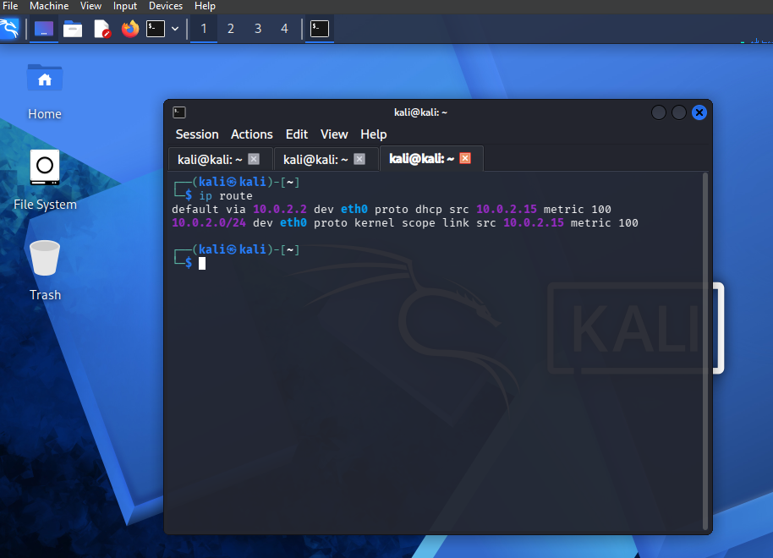
Identified the default gateway and routing path of the system using the ip route command to understand network traffic flow.

DNS footprinting
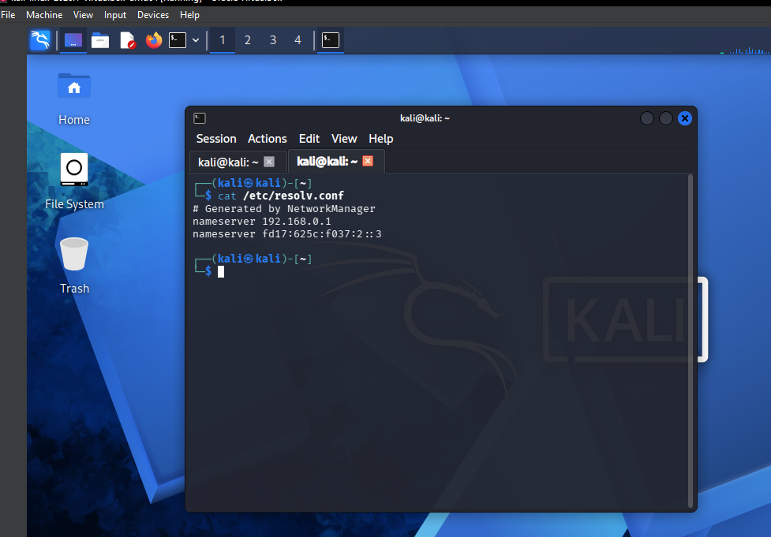
Displayed DNS configuration details showing configured name servers used by the system for domain resolution.

TASK 2: NETWORK SCANNING

Basic host scan
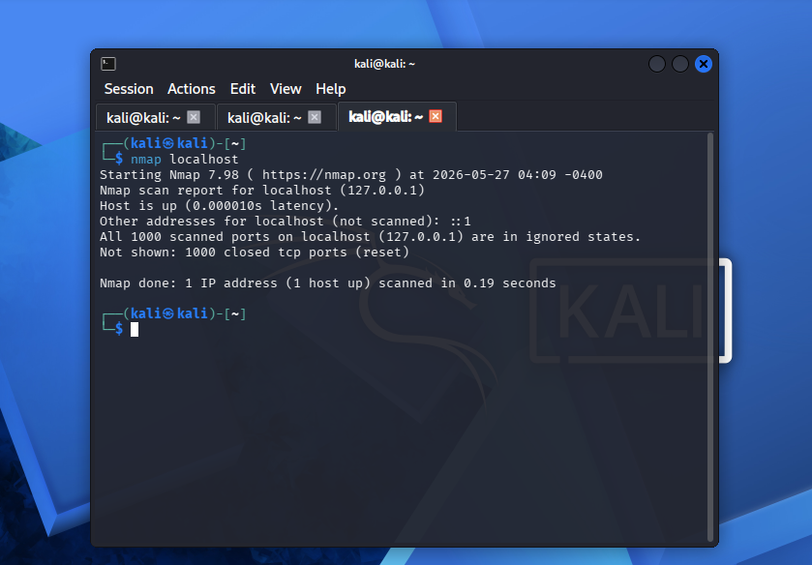
Performed a basic Nmap scan on the local machine to identify open ports and running services

Fast port scan
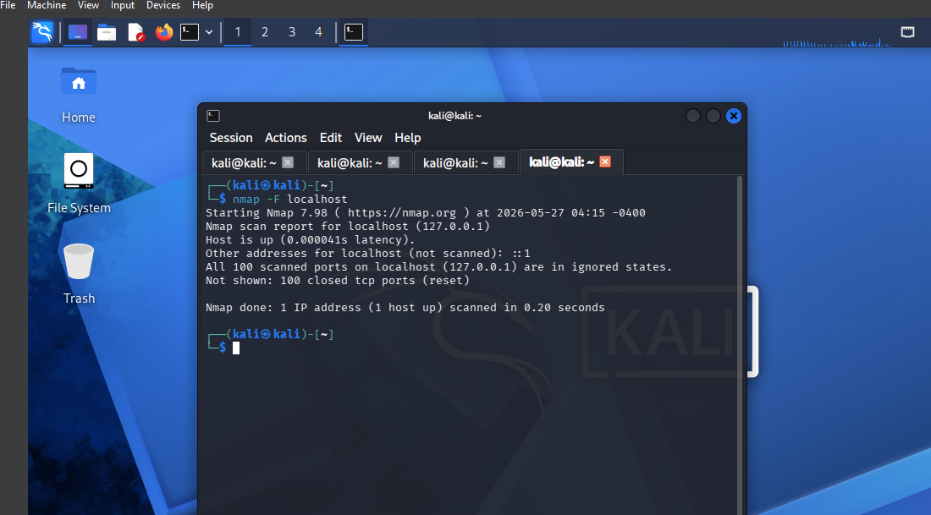
Executed a fast scan to identify commonly used open ports on the target system.

Service version detection
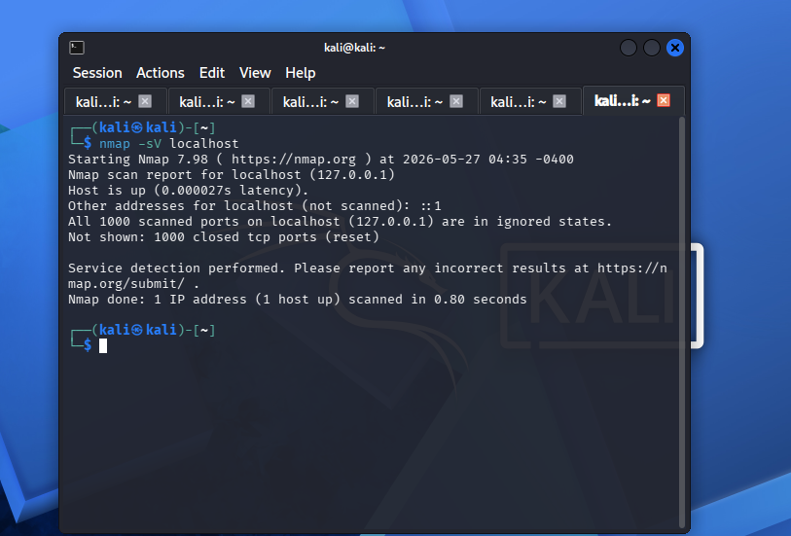
Performed service version detection to identify applications running on open ports

TASK 3: VULNERABILITY ASSESSMENT

Service and version enumeration
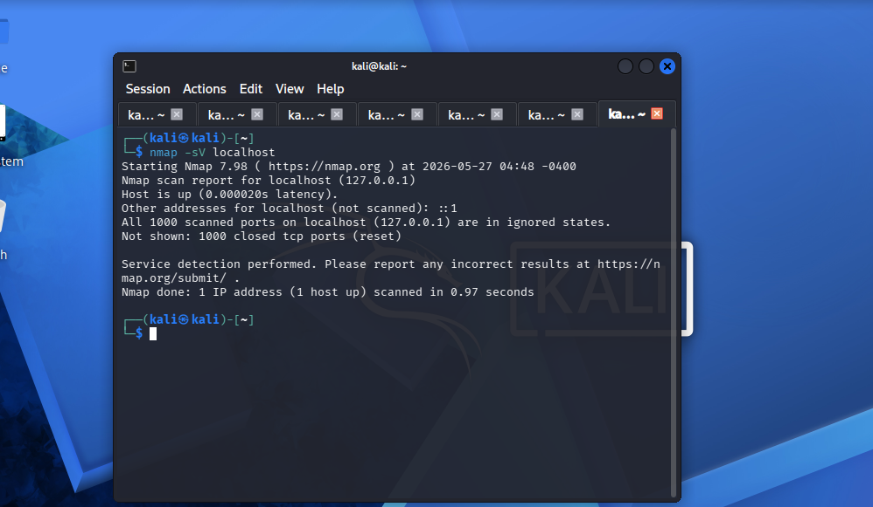
Performed service version detection to identify software versions running on open ports for vulnerability analysis.

Vulnerability Script Scan
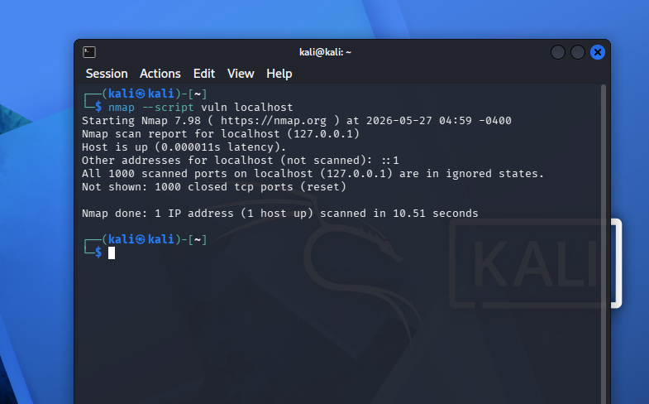
Executed Nmap vulnerability scanning scripts to assess the target system for known vulnerabilities and exposed services. The results indicated minimal exposure with most ports closed.

Port Risk Analysis
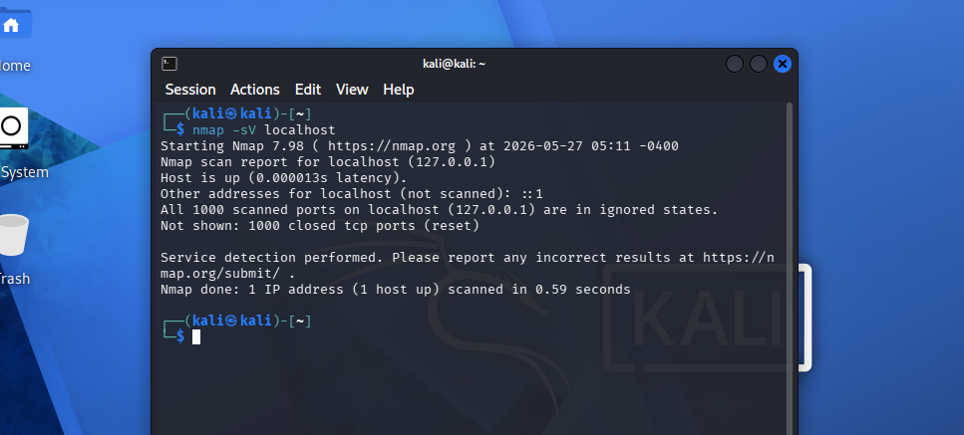
Conducted an Nmap vulnerability and port assessment scan on the local system .The scan revealed that all commonly scanned TCP ports were closed, indicating minimal network exposure.

TASK 4: LOG AUDITING

Authentication Log Review
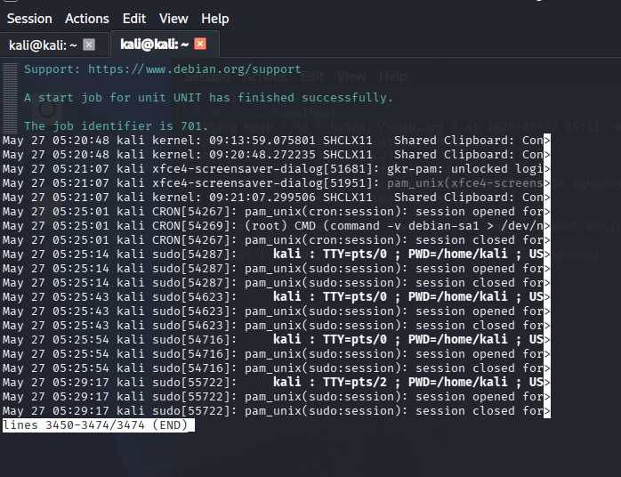
Examined system journal logs using journalctl to monitor authentication and system activity events.

Login History Review
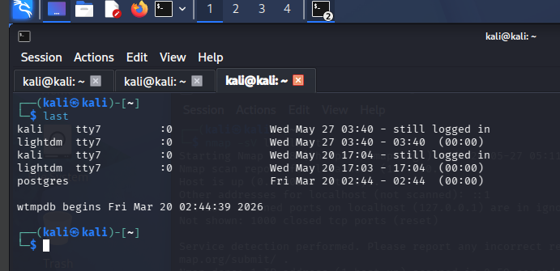
Retrieved historical login records of users accessing the system.

Current User Session Check
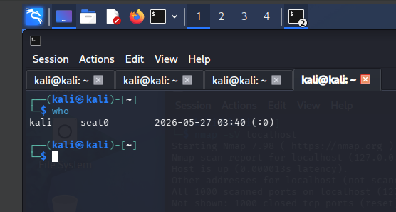

PROCESS OF ETHICAL HACKING

STEP 1: INFORMATION GATHERING

Identify target institution
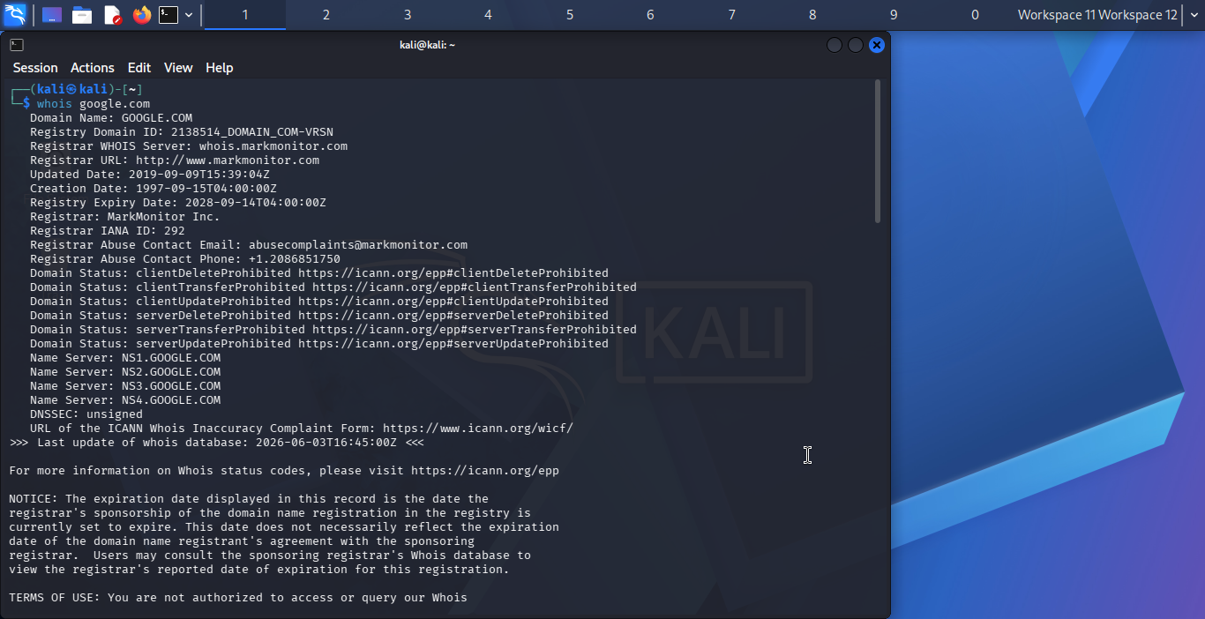
Performed a WHOIS lookup on the target institution to obtain domain registration and ownership information.

Identify institutions IP address
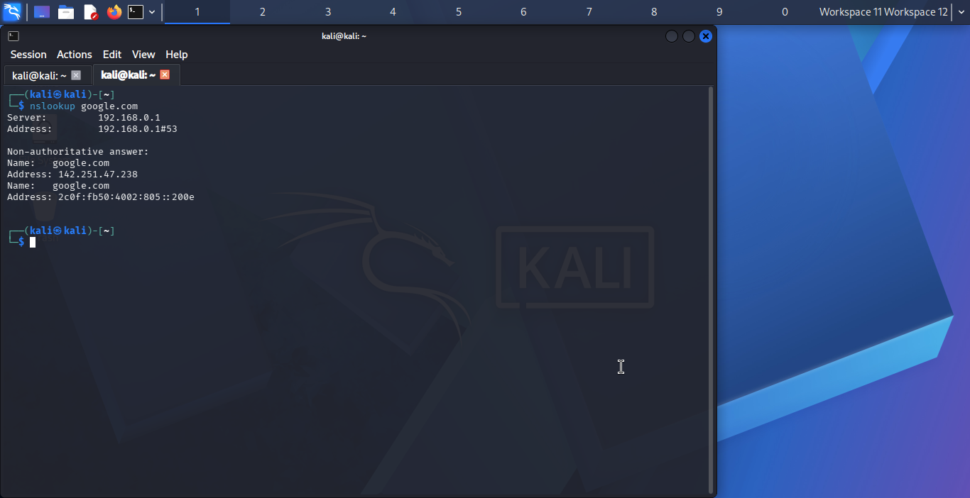
Resolved the target institution's domain name to its associated IP address.

Verify the Institution Website

Verified the target institution's official website and online presence.

Identify Open Services
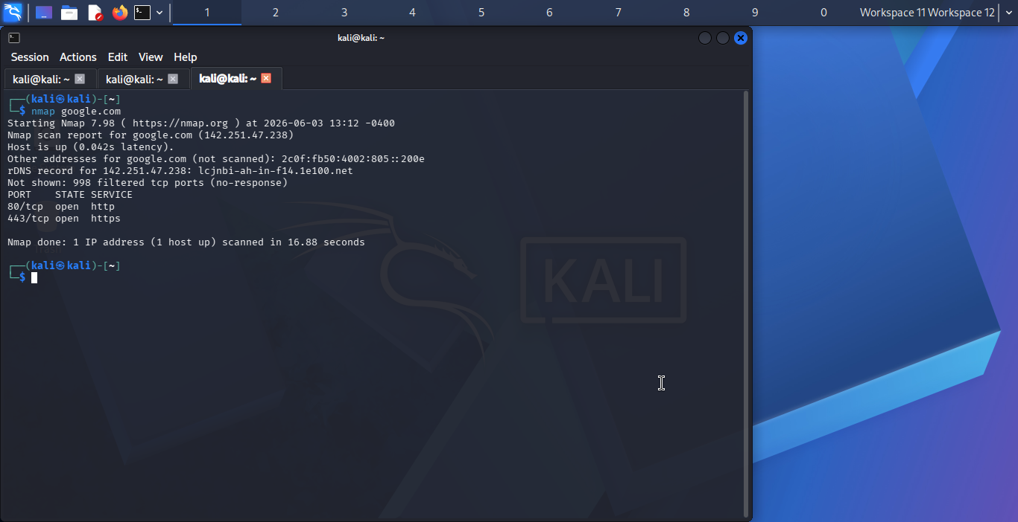.
Identified publicly accessible network services offered by the target institution.

Service version detection
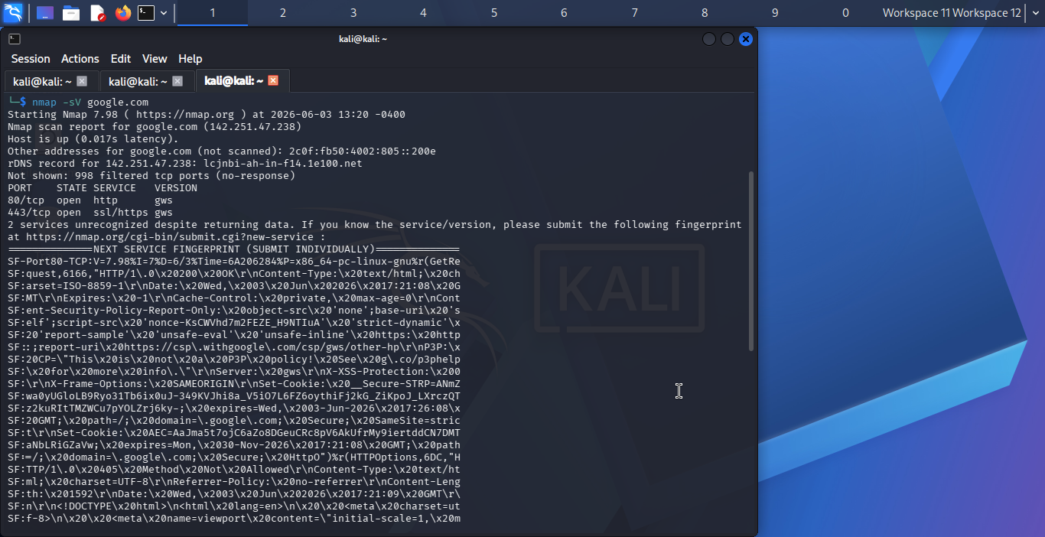
Enumerated service versions running on publicly accessible ports.

Identify Technologies Running on the Website
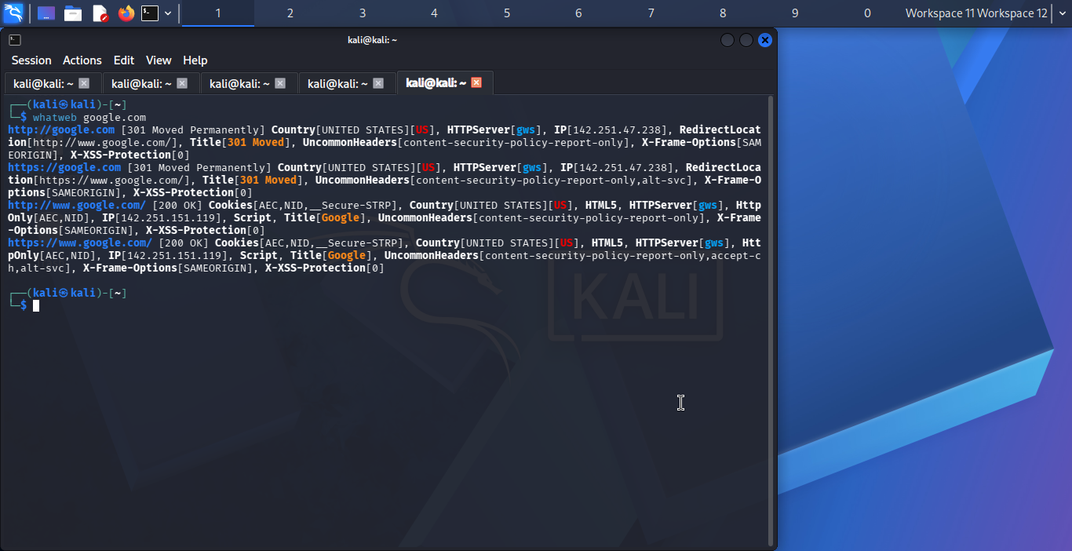
Performed web technology fingerprinting to determine software and frameworks supporting the target website.

STEP 2: SCANNING AND ENUMERATION

Discover all open ports
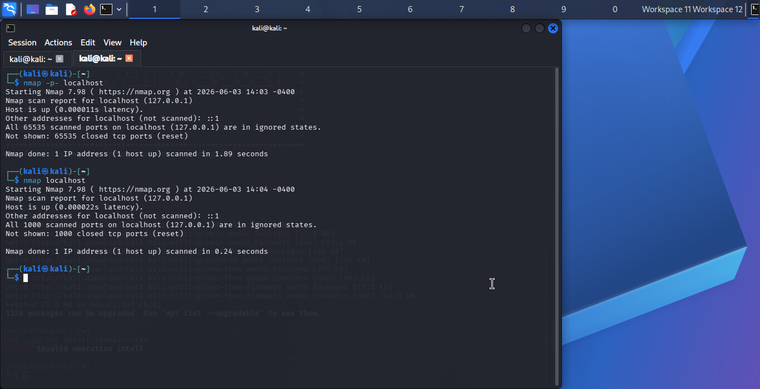
Performed port scanning to identify open ports and exposed services on the target system.

Identify the operating system
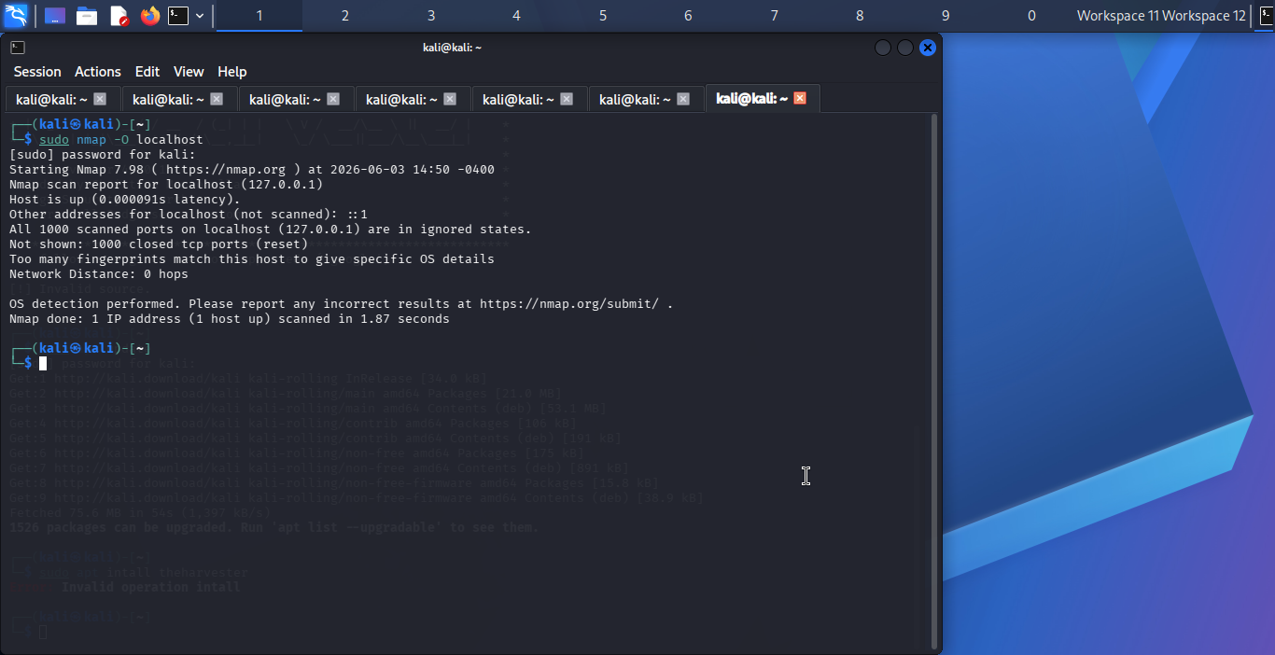
Performed operating system fingerprinting to identify the target platform.

